Equatorial disk
# Source: AI Source: Provided by: [Data Path: Persons Table -> ID Column: 1, Name_En Column: Motasem Essam] -> From: [ChatGPT] on [7/25/2026]
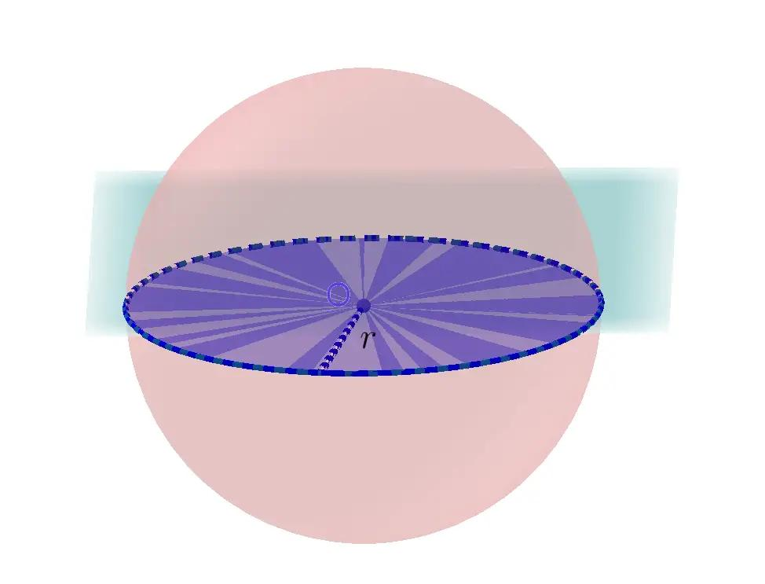
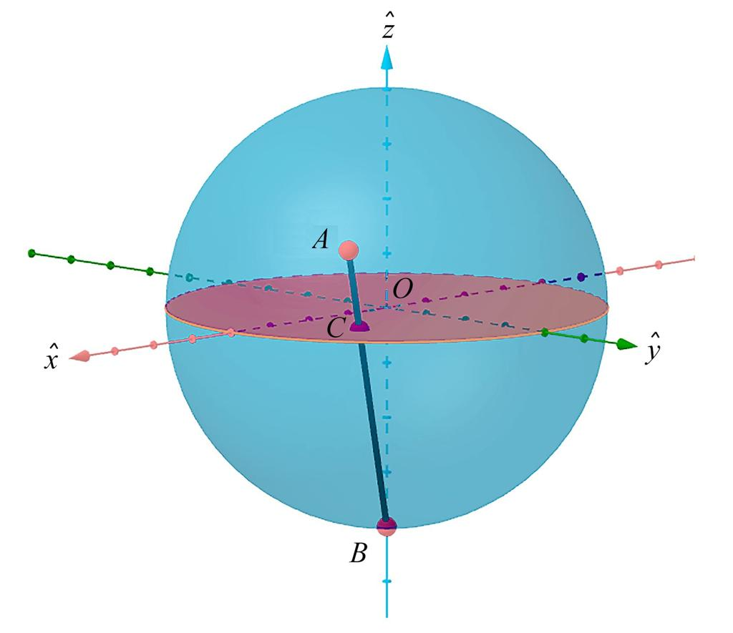
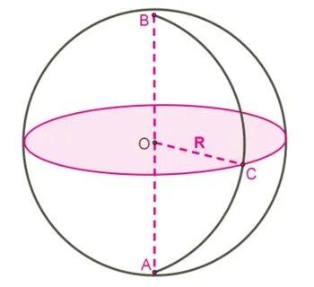

Definition
# Source: AI Source: Provided by: [Data Path: Persons Table -> ID Column: 1, Name_En Column: Motasem Essam] -> From: [ChatGPT] on [7/25/2026]
The equatorial disk is the filled circular region inside a sphere formed by the intersection of the sphere with its equatorial plane. The plane passes through the sphere's center and is perpendicular to the chosen axis, usually its rotational axis.
The equatorial disk includes every point inside the circular boundary, not just the circumference. Its boundary is the equatorial great circle.
Unlike the equatorial plane, which extends infinitely, the equatorial disk is a finite region with a radius equal to the sphere's radius.

Simple Definition
# Source: AI Source: Provided by: [Data Path: Persons Table -> ID Column: 1, Name_En Column: Motasem Essam] -> From: [ChatGPT] on [7/25/2026]
An equatorial disk is the flat, filled circle through the middle of a sphere, perpendicular to its chosen axis.
For Earth, imagine the circular region inside the planet at the level of the Equator.

Geometric Representation
# Source: AI Source: Provided by: [Data Path: Persons Table -> ID Column: 1, Name_En Column: Motasem Essam] -> From: [ChatGPT] on [7/25/2026]
Consider a sphere centered at $O=\left(0,0,0\right)$ with radius $R$, whose rotational axis is the $z$-axis.
The equatorial disk has the following properties:
- Center: $O=\left(0,0,0\right)$
- Plane: $z=0$
- Radius: $R$
- Diameter: $2R$
- Boundary: The equatorial great circle
- Shape: A filled circular disk
The disk is a two-dimensional cross-section of the sphere. It has area but no volume as a geometric disk of zero thickness.

Mathematical Representation
# Source: AI Source: Provided by: [Data Path: Persons Table -> ID Column: 1, Name_En Column: Motasem Essam] -> From: [ChatGPT] on [7/25/2026]
The equation of a sphere centered at the origin is
$$x^{2}+y^{2}+z^{2}=R^{2}$$
The equatorial plane is
$$z=0$$
Therefore, the equatorial disk is represented by
$$\boxed{x^{2}+y^{2}≤R^{2}, z=0}$$
The boundary circle is represented by
$$\boxed{x^{2}+y^{2}=R^{2}, z=0}$$
The inequality $≤$ includes the interior of the disk and its boundary, whereas the equality describes only the circular boundary.

Formulas
# Source: AI Source: Provided by: [Data Path: Persons Table -> ID Column: 1, Name_En Column: Motasem Essam] -> From: [ChatGPT] on [7/25/2026]
Let $R$ be the radius of the sphere.
Radius
$$r=R$$
Diameter
$$d=2R$$
Area of the disk
$$A=πR^{2}$$
Circumference of its boundary
$$C=2πR$$
Note: The disk's area is not the surface area of the sphere. It is the area of the flat circular cross-section.

Key Characteristics
# Source: AI Source: Provided by: [Data Path: Persons Table -> ID Column: 1, Name_En Column: Motasem Essam] -> From: [ChatGPT] on [7/25/2026]
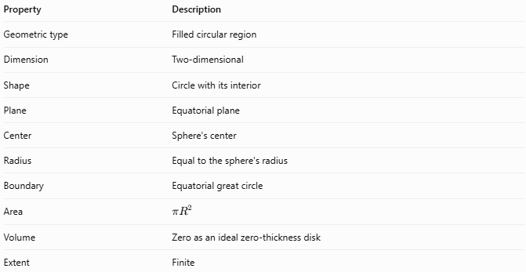
Property | Description
Geometric type | Filled circular region
Dimension | Two-dimensional
Shape | Circle with its interior
Plane | Equatorial plane
Center | Sphere's center
Radius | Equal to the sphere's radius
Boundary | Equatorial great circle
Area | $$πR^{2}$$
Volume | Zero as an ideal zero-thickness disk
Extent | Finite

Worked Example
# Source: AI Source: Provided by: [Data Path: Persons Table -> ID Column: 1, Name_En Column: Motasem Essam] -> From: [ChatGPT] on [7/25/2026]
Problem: A sphere has a radius of $7\text{ cm}$. Find the area and boundary circumference of its equatorial disk.
Given:
$$R=7\text{ cm}$$
Step 1 — Calculate the area
$$A=πR^{2}$$
$$A=π{\left(7\right)}^{2}$$
$$\boxed{A=49π{\text{ cm}}^{2}≈153.94{\text{ cm}}^{2}}$$
Step 2 — Calculate the circumference
$$C=2πR$$
$$C=2π\left(7\right)$$
$$\boxed{C=14π\text{ cm}≈43.98\text{ cm}}$$
The disk has an area of approximately $153.94{\text{ cm}}^{2}$, and its boundary measures approximately $43.98\text{ cm}$.

Equatorial Disk vs. Related Concepts
# Source: AI Source: Provided by: [Data Path: Persons Table -> ID Column: 1, Name_En Column: Motasem Essam] -> From: [ChatGPT] on [7/25/2026]
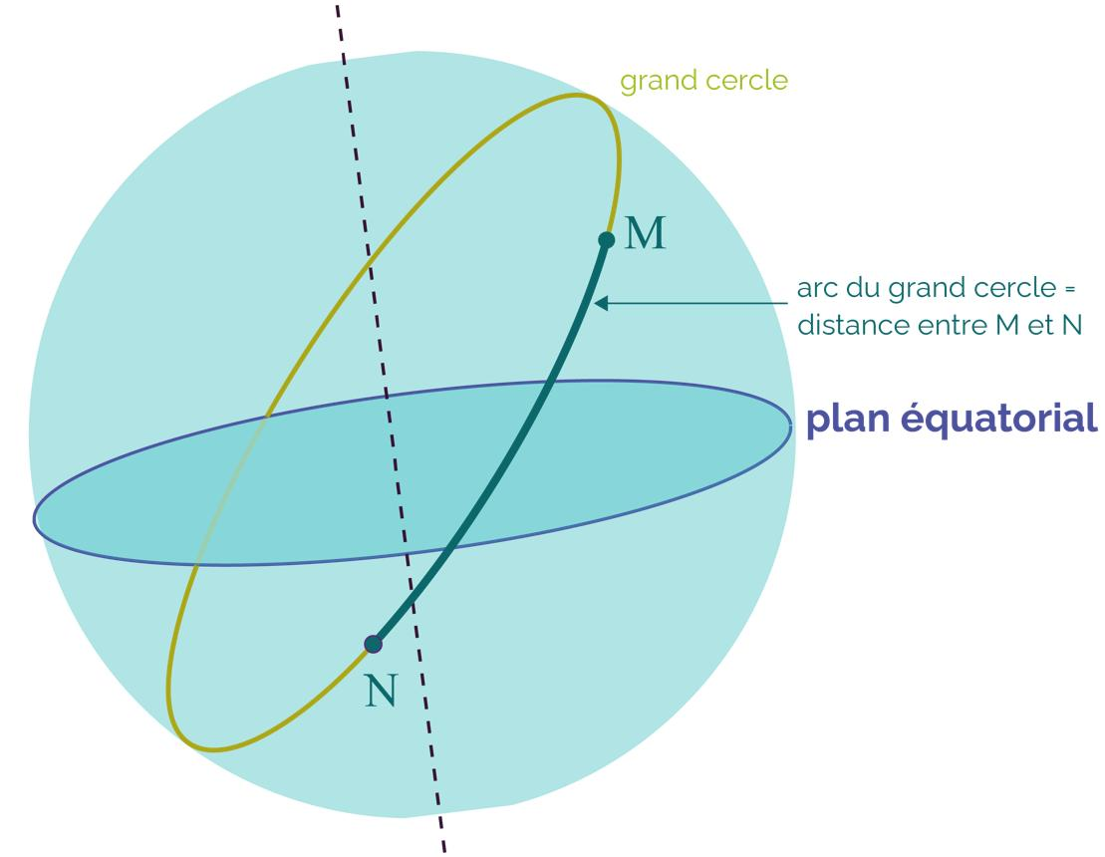
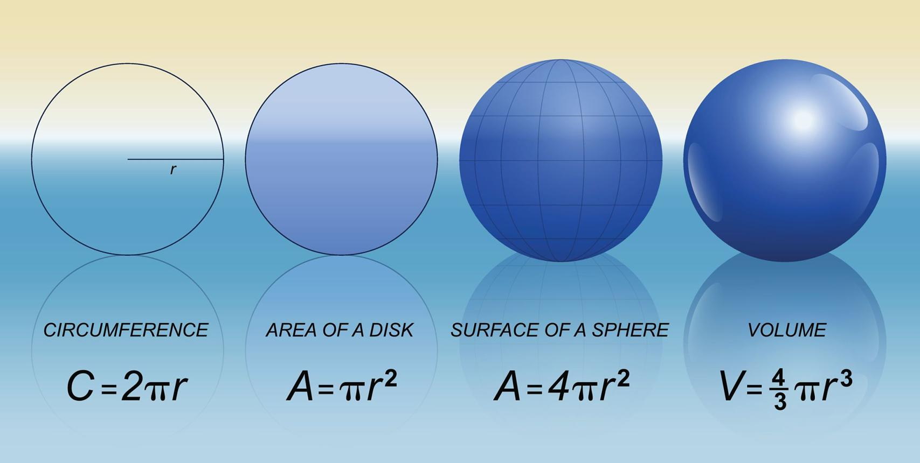
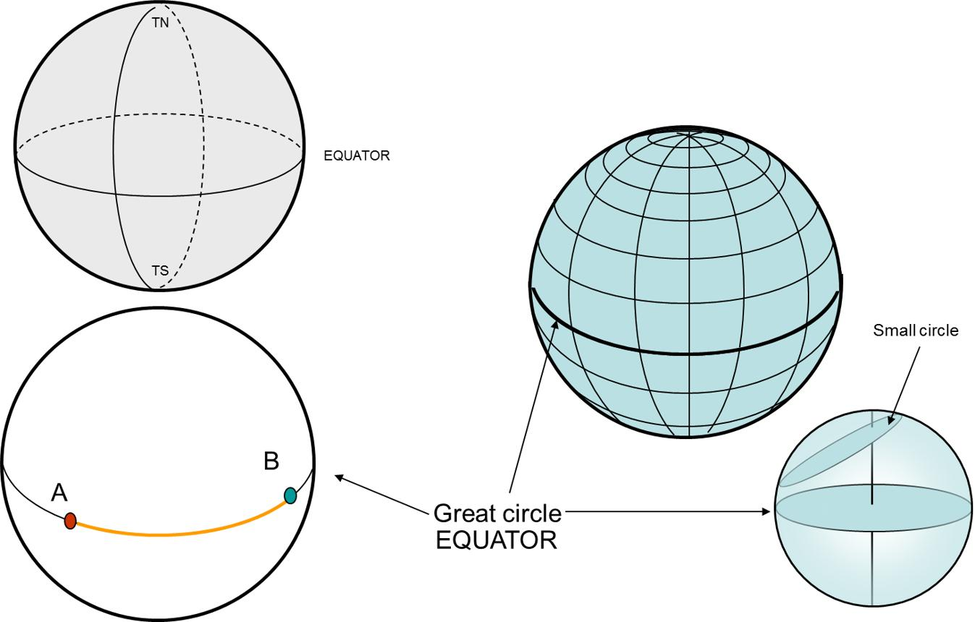
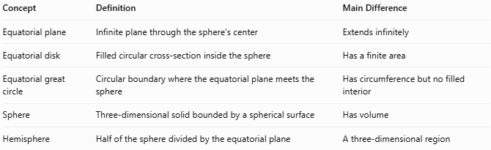
Concept | Definition | Main Difference
Equatorial plane | Infinite plane through the sphere's center | Extends infinitely
Equatorial disk | Filled circular cross-section inside the sphere | Has a finite area
Equatorial great circle | Circular boundary where the equatorial plane meets the sphere | Has circumference but no filled interior
Sphere | Three-dimensional solid bounded by a spherical surface | Has volume
Hemisphere | Half of the sphere divided by the equatorial plane | A three-dimensional region

Applications
# Source: AI Source: Provided by: [Data Path: Persons Table -> ID Column: 1, Name_En Column: Motasem Essam] -> From: [ChatGPT] on [7/25/2026]
- Geometry: Studying circular cross-sections of spheres.
- Physics: Modeling cross-sectional areas through spherical objects.
- Engineering: Calculating circular sections of spherical components.
- Computer graphics: Rendering and analyzing slices through spherical models.
- Astronomy: Representing idealized cross-sections through planets and other spherical bodies.

Key Points
# Source: AI Source: Provided by: [Data Path: Persons Table -> ID Column: 1, Name_En Column: Motasem Essam] -> From: [ChatGPT] on [7/25/2026]
- The equatorial disk is the filled circular cross-section at the sphere's equator.
- It lies in the equatorial plane and passes through the sphere's center.
- Its radius equals the sphere's radius.
- Its area is $πR^{2}$.
- Its boundary is the equatorial great circle.
- It is a two-dimensional region, not a three-dimensional solid with positive volume.

Conclusion
# Source: AI Source: Provided by: [Data Path: Persons Table -> ID Column: 1, Name_En Column: Motasem Essam] -> From: [ChatGPT] on [7/25/2026]
The equatorial disk is the finite, filled circular region obtained by cutting a sphere through its center along the equatorial plane. It has the same radius as the sphere and an area of $πR^{2}$. Understanding the distinction between the disk, its boundary great circle, and the infinite equatorial plane is essential for describing spherical geometry precisely.

